PROJECT ON HOUSE PRICING

Data Description –
The dataset represents residential real estate listings across multiple cities and localities in India. It captures detailed property-level attributes such as property type, number of bedrooms (BHK), built-up area, price, price per square foot, and year of construction. In addition, the dataset includes contextual variables such as furnishing status, floor information, age of the property, nearby amenities (schools, hospitals, public transport), parking availability, and security features.

Objectives-
• Analyse pricing patterns across cities, localities, and property types.
• Identify key factors influencing property prices (BHK, size, amenities, age of property).
• Compare average price and price-per-sqft trends to understand market dynamics.
• Assess the impact of location-specific features such as schools, hospitals, and transport accessibility.
• Build an interactive single-sheet Power BI dashboard for quick insights and decision support.

Analyses-
Technique used here used is POWER BI for dashboard

DASHBOARDS:

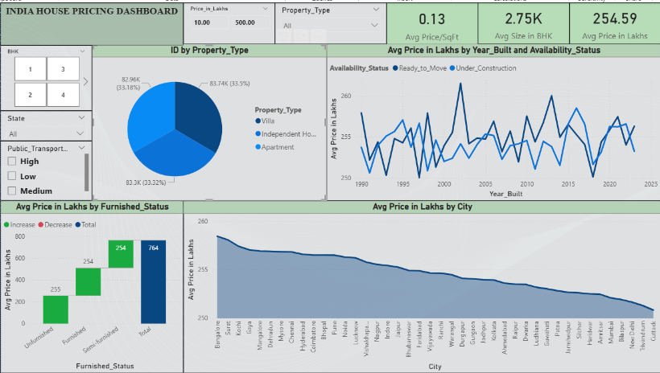

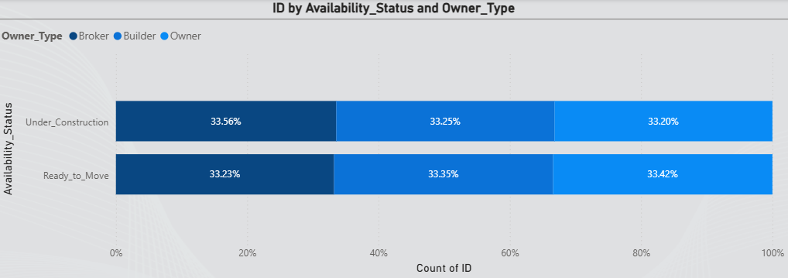
1. Market-Level Indicators (KPIs)
The KPI section gives an instant understanding of the overall market:
- Average Price per SqFt: 0.13 Lakhs (₹13,000), indicating a relatively premium market.
- Average Property Size: 2,750 SqFt, suggesting dominance of mid-to-large residential units.
- Average Price: 254.59 Lakhs, showing high-value transactions typical of metropolitan cities.
2. Property Type Composition
- A pie chart showing distribution of Property Types (Apartment, Independent House, Villa) reveals an almost equal split.
- This indicates that the dataset captures a balanced representation of all major residential formats, making comparative price analysis more reliable.
3. Price Trend by Year Built
The line chart comparing Avg Price over construction years, divided into:
- Ready_to_Move
- Under_Construction
It shows that both categories follow similar pricing patterns. Despite fluctuations across years, pricing remains relatively stable, reflecting consistent market conditions and steady buyer demand. This trend supports long-term planning for developers and investors.

4. Effect of Furnishing on Pricing
The waterfall chart analysing Avg Price by Furnished Status shows minor differences among:
- Unfurnished
- Semi-Furnished
- Furnished
All categories contribute nearly equally to the total price, indicating that furnishing level does not significantly influence overall pricing in this dataset. This insight is particularly relevant for owners assessing renovation or furnishing investments.

5. City-Wise Average Price Ranking
The area chart visualizing Avg Price by City highlights:
- Higher prices in cities like Bangalore, Surat, Kochi, and Gaya.
- Lower prices in smaller markets such as Cuttack, Tirupati, and Bilaspur.
This ranking provides a clear perspective on regional affordability and helps users identify both high-end and budget-friendly cities.

6. Ownership Pattern by Availability Status
The new 100% stacked bar chart comparing Owner_Type (Broker, Builder, Owner) across:
- Under_Construction
- Ready_to_Move
shows a remarkably balanced distribution:
- Each owner type accounts for approximately one-third of listings in both availability categories.
This indicates a highly uniform market structure, where the role of brokers, builders, and individual owners remains consistent regardless of whether the property is new or already completed.
Key insights:
- Builders are not disproportionally dominant in under-construction properties.
- Owners and brokers maintain similar participation in both categories.
- The uniform distribution suggests stable and well-distributed market competition.

7. Interactive Filters for Custom Exploration
Filters such as BHK, State, Public Transport Rating, Property Type, and Price Range enable users to analyze specific market segments.
These slicers support questions like:
- How do 3 BHK prices vary across states?
- Do properties with “High” public transport accessibility command a premium?
- How do prices shift within a specific budget range?

Overall Conclusion
- The market is high-value, with premium per-sq ft rates and relatively large average unit sizes.
- Property types are almost evenly represented, supporting balanced analysis.
- Long-term pricing trends are stable and largely unaffected by construction status.
- Furnishing levels have limited impact on pricing, whereas location is a major driver.
- City-level pricing variation is significant, defining clear premium and affordable markets.
- Ownership patterns remain uniform across both ready and under-construction projects, indicating a consistent market ecosystem.

